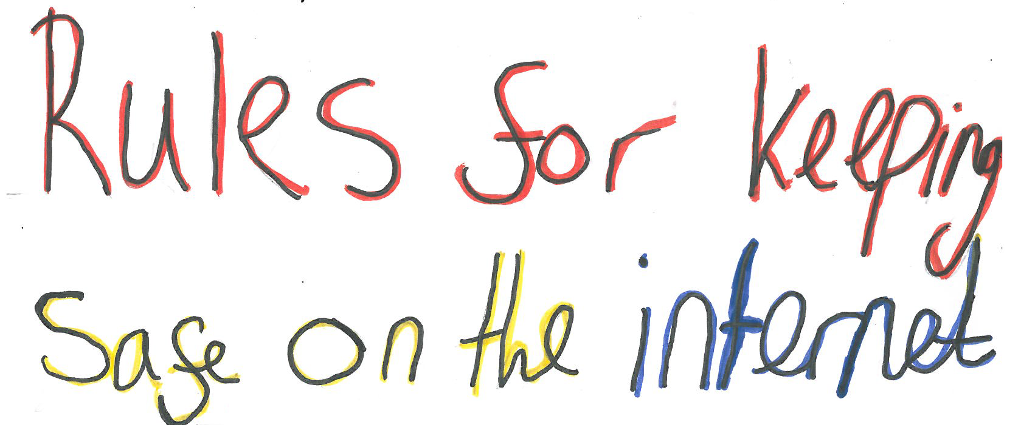
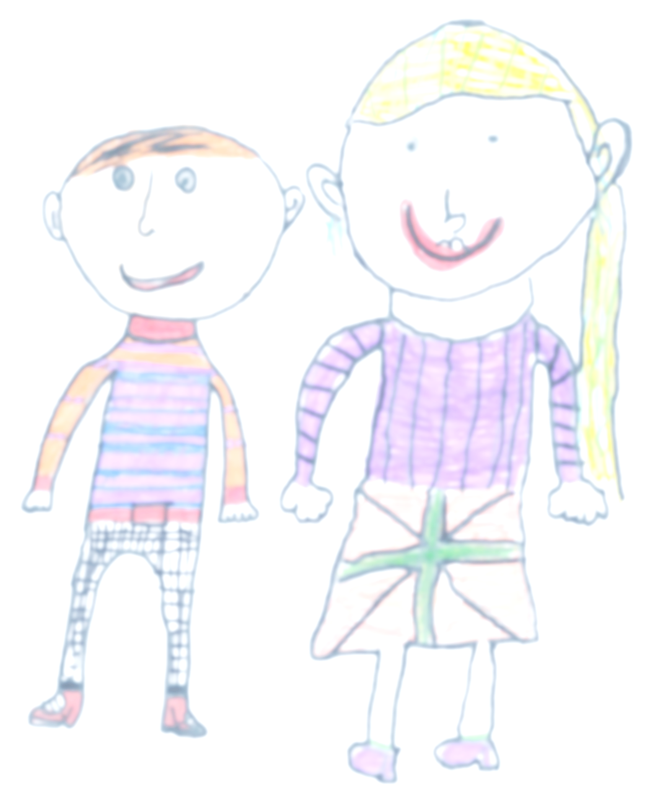
Safe Keep all of your personal information
safe and private

Meet Never arrange to meet strangers

Accept Be very careful which information
and requests you accept

Reliable Can you be sure what you are
reading or seeing is true? Think
hard or ask a grown-up before
believing things

Tell If anything is wrong or strange, or
you don’t trust someone, tell an
adult straight away

