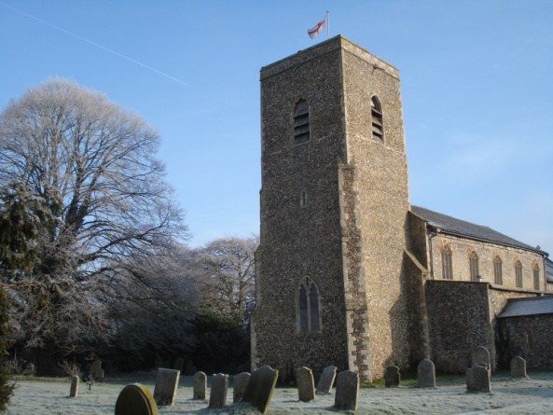

Sunday 2nd December at 7 pm
The Plough Inn, Marsham

Tables of up to 6 people
tickets £3 per person

Tables need to be pre-booked by ringing
Jean George on 01263 735383
or email Nicola.hibberd@talktalk.net

All money raised will go towards Marsham Church

