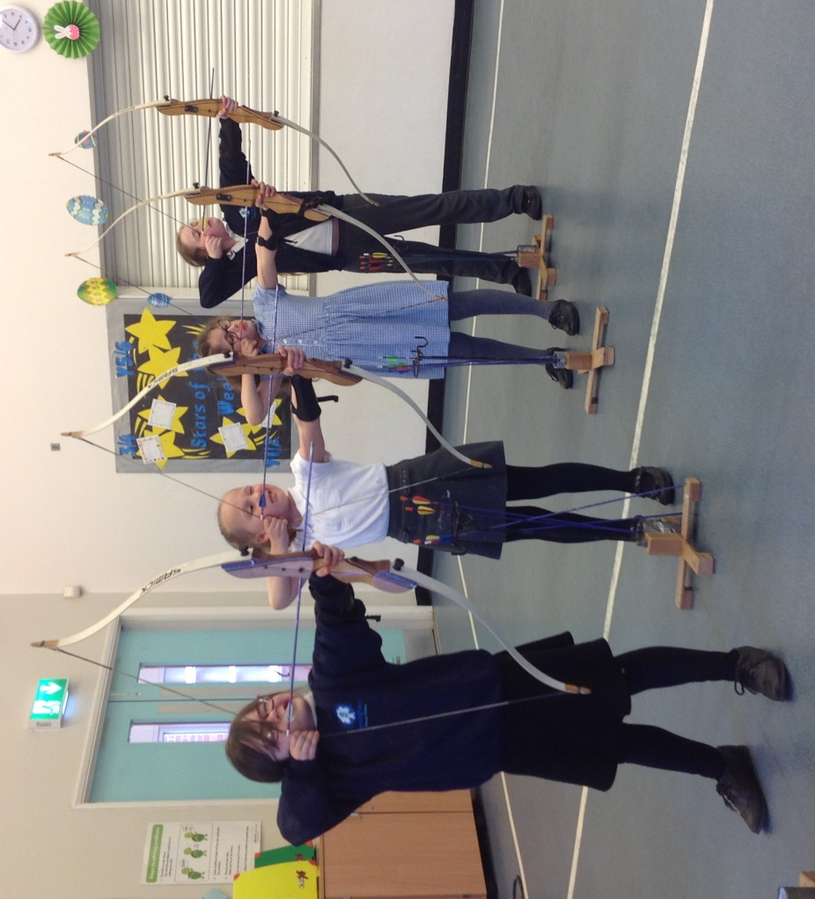

Evidencing the Impact of Primary PE and Sport Premium
2017-2018

Hevingham and Marsham Primary School Partnership Vision for PE

We believe that physical education is an essential part of a child’s educational development. We aim to develop a broad, rich and engaging curriculum offering a variety of activities to enhance skills in PE. Positive and inclusive participation in PE will enable children to build self-esteem, team work and positive values and attitudes in PE and across the curriculum.

We aim to:
- Develop confidence, skills and knowledge
- Develop physical literacy
- Provide new quality sporting opportunities
- Be proud of achievements
- Promote fair play and respect
- Encourage children to live healthy, active lives
- Engage in competitive sports and activities

There are 5 key indicators that our schools expect to see improvement across:
- the engagement of all pupils in regular physical activity - the Chief Medical Officer guidelines recommend that all children and young people aged 5 to 18 engage in at least 60 minutes of physical activity a day, of which 30 minutes should be in school
- the profile of PE and sport is raised across the school as a tool for whole-school improvement
- increased confidence, knowledge and skills of all staff in teaching PE and sport
- broader experience of a range of sports and activities offered to all pupils
- increased participation in competitive sport

How we use the primary PE and sport premium at Hevingham and Marsham Primary School Partnership

Like all schools we intend to use this funding to make additional and sustainable improvements to the quality of our PE and sport offer. This means that we use the premium to:
- develop or add to the PE and sport activities that your school already offers
- make improvements now that will benefit pupils joining the school in future years

We do not use your funding to:
- employ coaches or specialist teachers to cover planning preparation and assessment (PPA) arrangements as this comes out of our core staffing budgets
- teach the minimum requirements of the national curriculum - including those specified for swimming

Key achievements to date: | Areas for further improvement and baseline evidence of need:
- Upskilling staff members and purchase of new dance resources  - Improvement of our outdoor area and lunchtime provision. | - We are looking at improving our outdoor area next to the playground to make it more suitable for use in poor weather.  - The children have said they would like climbing walls. This would be introducing a new activity to the children and enable them to have more active lunchtimes and increase desired behaviour

Meeting national curriculum requirements for swimming and water safety | Please complete all of the below*:
What percentage of your current Year 6 cohort swim competently, confidently and proficiently over a distance of at least 25 metres? | 88.9% (2 out of 18 unable to make the 25m but swam 10m and 15m respectively).
What percentage of your current Year 6 cohort use a range of strokes effectively [for example, front crawl, backstroke and breaststroke]? | 88.9%
What percentage of your current Year 6 cohort perform safe self-rescue in different water-based situations? | 89.9%
Schools can choose to use the Primary PE and Sport Premium to provide additional provision for swimming but this must be for activity over and above the national curriculum requirements. Have you used it in this way? | No
*Schools may wish to provide this information in April, just before the publication deadline.

 | Academic Year: 2017/18 |  | Total fund allocated: £18,050 (17-18 allocation and £4,649 used from 16-17 allocation). |  | Date Updated:20/03/2018
 | Key indicator 1: The engagement of all pupils in regular physical activity – Chief Medical Officer guidelines recommend that primary school children undertake at least 30 minutes of physical activity a day in school |  |  |  |  |  |  |  | Percentage of total allocation:
 |  |  |  |  |  |  |  |  | 90.6%
 | School focus with clarity on intended impact on pupils: |  | Actions to achieve: |  | Funding allocated: |  | Evidence and impact: |  | Sustainability and suggested next steps:
 | School will purchase a Pirate Ship for the playground that will allow children to develop core strength and physical skills such as climbing etc.  An increase in the activity level of children during lunchtimes.  EYFS resources will be purchased in order to support the early development of gross motor skills that are essential to build upon in KS1 and KS2 PE sessions.  Lunchtime resources will be purchased in order to allow all children to continue to be active during lunchtime and further develop their gross motor skills. |  | Quotes need to be gathered and school council will be consulted as to what the school children would like on the playground. Pirate ship to be ready by Summer term.  EYFS lead to identify gaps in provision and create a list of resources that will support children to achieve the ELG’s.  Playtime leader did an audit of playtime resources and identified that certain pieces of equipment needed replacing in order to be safe. Discussion with children allowed them to identify what equipment they wanted. |  | £13,790  £2561 |  | Within the first couple of weeks of the ship being in school, many children were unable to use the equipment correctly due to lack of core body strength; this is no longer the case. Children are always using the ship to play creatively.  Children continuously use the outdoor equipment.  There have been fewer incidents on the playground as children are engaged in using the equipment correctly and set up physical challenges regularly. |  | Maintenance of ship and annual safety testing.  Continue to monitor if any other gaps become evident. Maintain equipment.  Be aware of different items being needed during the summer term as equipment was ordered for Autumn and Winter time.  Bench mark children and identify those that are vulnerable and encourage them to complete physical activity at lunchtimes (MSA involvement)  Organise trips to sporting events in order to give children high aspirations.  TA to take classes weekly to do gardening and other physical outdoor activities for them to experience a different type of physical activity.  Well-being needs identified and addressed accordingly.
 | Key indicator 2: The profile of PE and sport being raised across the school as a tool for whole school improvement |  |  |  |  |  |  |  | Percentage of total allocation:
 |  |  |  |  |  |  |  |  | 0%
 | School focus with clarity on intended impact on pupils: |  | Actions to achieve: |  | Funding allocated: |  | Evidence and impact: |  | Sustainability and suggested next steps:
 | Increased sporting activity at lunchtime to ensure that children have a high level of engagement in purposeful activities. |  | Identify training for MSA to support physical development. |  | Identified cluster funding |  | MSA training to support |  | To ensure that PE and sporting activities have a higher profile on the schools SIDP.  CPD is targeted and specific to need.  Identify sports star of the week.  Purchase some active posters to inform children and place around the school.  Healthy eating/sports week activities ie Sports day. Charity events ie sports relief.  Mile a day signage to inform children about where to run and how far they have been/have to go.
Key indicator 3: Increased confidence, knowledge and skills of all staff in teaching PE and sport |  |  |  |  |  |  |  | Percentage of total allocation:
 |  |  |  |  |  |  |  | 0%
School focus with clarity on intended  impact on pupils: |  | Actions to achieve: |  | Funding  allocated: |  | Evidence and impact: |  | Sustainability and suggested  next steps:
None identified at the beginning of 2017-2018 as staff had recently had CPD. |  | - |  | - |  | - |  | Discuss with staff in Summer term what gaps there are for training.  Identify training that will support staff in their teaching of PE.
Key indicator 4: Broader experience of a range of sports and activities offered to all pupils |  |  |  |  |  |  |  | Percentage of total allocation:
 |  |  |  |  |  |  |  | 8.4 %
School focus with clarity on intended  impact on pupils: |  | Actions to achieve: |  | Funding  allocated: |  | Evidence and impact: |  | Sustainability and suggested  next steps:
Identify opportunities for children to increase the range of physical activities that they can experience.  To enable children to encounter less common sports. Children to participate in taster sessions and have the opportunity to continue the support in local clubs. |  | To identify unusual sport/activities for our children to experience through workshops in class time.  Afterschool clubs identified and run by the school – multi-skills, athletics, archery. |  | £440  £1079 |  | School booked a Skateboarding and Dance workshop for all classes.  Clubs have a good uptake and children have the option of which sport to do. |  | Vary sports clubs offered using child input.  Continue to identify unusual sport workshops to offer children.  Consider funding some after school clubs to ensure high levels of engagement in the future when sports funding is no longer available.  Look at gardening clubs to support physical activities
Key indicator 5: Increased participation in competitive sport |  |  |  |  |  |  |  | Percentage of total allocation:
 |  |  |  |  |  |  |  | 1.0%
School focus with clarity on intended  impact on pupils: |  | Actions to achieve: |  | Funding  allocated: |  | Evidence and impact: |  | Sustainability and suggested  next steps:
To identify opportunities for children to compete in the wider community to achieve and pass challenges.  Maintain inter school sport competitions- netball, football, cross country and tag rugby.  Increased confidence in enjoyment in team sporting events.  To offer transport for children to sporting events |  | Ensure communication with cluster and further afield to ensure all opportunities are taken up.  Children identified if they show talent in an area and competitions matched to their need. |  | £180 |  | Children have football training weekly delivered by a HLTA.  School enter the North Norfolk Football league and are being very successful (semi-finals coming up).  Dodgeball tournament was attended by Year 6 pupils during school and workshops were run by the high school. |  | James Green will be attending FA level 1football coaching  Children to become sports peer mentors in Year 5/6 to support younger children.

